Project: |  | SketchApp
Team No.: |  | 11
Class: |  | CSE 3310.003 - Fall 2020
Module: |  | System Requirements Analysis (SRA)
Deliverable: |  | SRA Document
Version: |  | [1.1] | Date: | [10/22/2020]

Contributors

Gabriel de Sa
Lucas Streanga
Luke Brown
Saugat Pandey
David Rademacher

Revision History
Version number | Date | Originator | Reason for change | High level description of changes
1.0 | 10/06/2020 | David Rademacher | Initial draft
1.1 | 10/22/2020 | David Rademacher | Increment 2 complete

TABLE OF CONTENTS

1. Introduction and Project Overview iv
2. Objectives v
2.1 BUSINESS Objectives v
2.2 SYSTEM Objectives v
3. Project Context Diagram vi
4. Systems Requirements vii
4.0 Requirements Overview vii
4.1 “Login” Requirements vii
4.2 “Using the Canvas” Requirements vii
4.3 “Drawing Categorization” Requirements viii
4.4 “Comments, Voting, and Reporting” Requirements viii
4.5 “Database search” Requirements viii
4.6 “Following and Filtering” Requirements ix
4.7 “Profile” Requirements ix
5. Software Processes and Infrastructure x
5.1 Hardware and Infrastructure x
5.2 Conceptual Data Model - Database x
5.3 UML Diagrams xi
5.4 Screen Shots xx
5.5 Test Plan xx
6. Assumptions and Constraints xxi
6.1 ASSUMPTIONS xxi
6.2 CONSTRAINTS xxi
6.3 Out of Scope material xxi
7. Delivery and Schedule xxii
8. Stakeholder Approval Form xxiii
Appendix: xxiv

1. Introduction and Project Overview

We aim to create a fun and expansive application for Android by the name of SketchApp. The full specifications of the application will be explained in this document, but in a high-level sense we will create an environment for users to converse with each other and share images and drawings as well as allow users to create drawings using our tool. The app will be easy to use and will be a more relaxed social platform for our users. In addition to the requirements listed in this document, we are open to adding more features as our user base requests them. The project will be completed and presented by December 8th of 2020.

2. Objectives

2.1 Business Objectives
The following is a list of business objectives:
Objective 1:
• User Registration: Users must provide personal information in order to access and view the system. The personal information requested will be:
- Username
- Password
  - Minimum 8 Characters, 1 Capital Letter, 1 Number.
- First Name, Last Name
- E-mail address
Objective 1a:
• Category Selection: Part of the user registration process will be to follow certain categories of Animals:
categories:
Bear, Bee, Bird, Cat, Cow, Dog, Dolphin, Duck, Elephant, Fish, Frog, Horse, Mouse, Penguin, Rabbit, Sheep, Snake, Whale.
Objective 2:
• Login: Users must login using username and password provided during customer registration.
Objective 3:
• Feed: After login users will be directed to their “feed,” a section of the app that shows images scrapped from Reddit, as well as images drawn by friends.
- Allows users to view “real” pictures of followed animals.
- Allows users to see pictures drawn by other users.
- Allows users can like posts.
- Allows users to select post.

Objective 4:
• Posts: In the feed users will be allowed to select posts, and view comments, like or report.
- Users will click post, which will open post from feed and take over the view board.
- User can then like, comment (undecided), or report post.
  - Report post if post is not appropriate or tagged incorrectly.
Objective 5:
• Draw: User will then be allowed to draw a post, where the app will try to guess what they are drawing as they draw.
- User is prompted to drawing board.
- User has option to clear the board.
- Submit and Cancel buttons available.
- If submitted the drawing is processes through the neural network, and the category is determined. User is asked to confirm category.
  - Once category is confirmed drawing is posted to users’ feed.
Objective 6:
• User Homepage: In the Users homepage, the user will have the option to see all posts made by user. As well as see the posts that the user has liked.
- See owned posts.
- Delete Post.
- See liked posts.
- Change followed Categories.
- Discover New Categories.
Objective 7:
• Settings: User will have the ability to control color scheme of app, change post view settings, and delete user account.
- User can change color scheme of SketchApp.
  - Light Mode
  - Dark Mode
- User can change types of posts seen.
  - Only drawn posts
  - Only scraped posts.
  - Both.
- Users can delete their account, including all account data and posts from SketchApp database.

2.2 System Objectives
The following is a list of system objectives:
Objective 1: SketchApp will be an Android OS application.
Objective 2: Web scraping functionality will utilize Reddit for animal images.
Objective 3: M.L. will utilize Google Doodles data for training drawing images.
Objective 4: M.L. will use TensorFlow for Neural Network Implementation.
Objective 5: App will communicate with Firebase, and SQLite to gather and contain app data.
Objective 6: SketchApp will require no further development or maintenance after production date.
Objective 7: SketchApp will use proprietary tools for web scraping. Reddit will be used to gather images for user feeds.
- Credit to Reddit and Redditor will be placed in every post.

3. Project Context Diagram

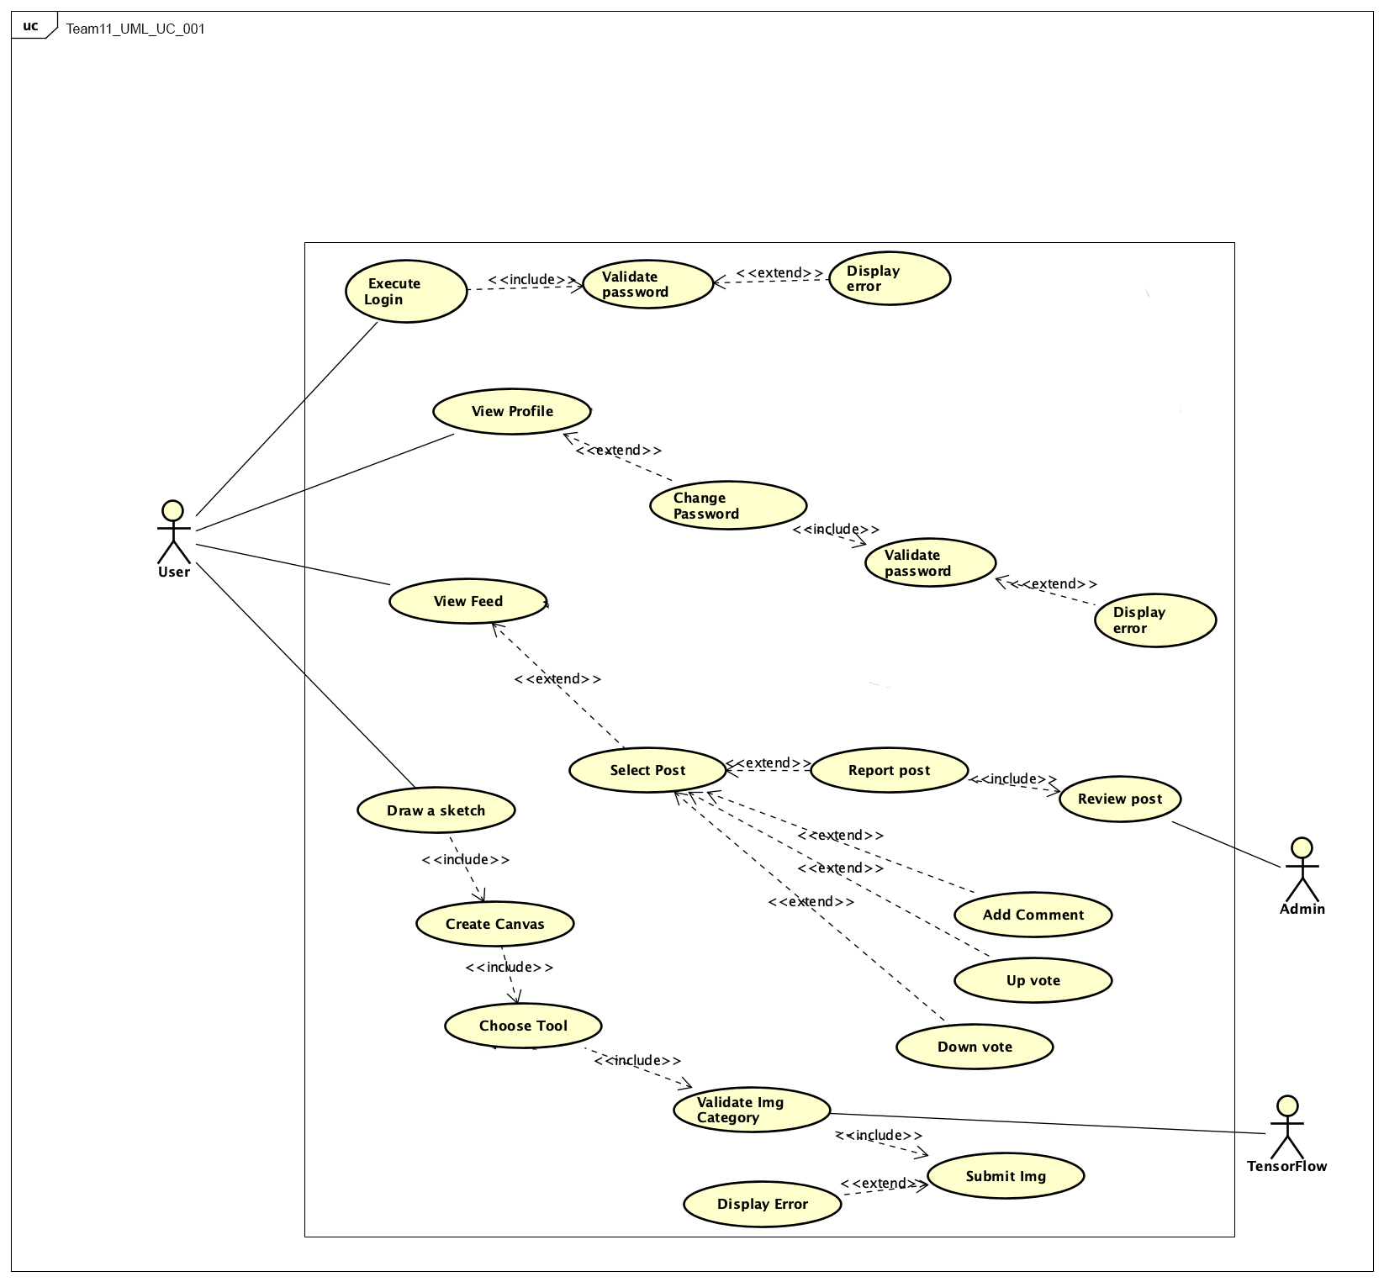

4. Systems Requirements

4.0 Requirements Overview
The following requirement forms provide details about how each specific area of the application will accomplish its objective. The forms are grouped by areas of the application in which they operate. These subsystems are: Login, Using the Canvas, Drawing Categorization, Comments, Voting, and Reporting, Database Search, Following and Filtering, and Profile.

4.1 “Login” Requirements
Requirement title | Login
Sequence No. | 1
Short description | How the system accepts login information
Description | The system will have two entry boxes, email/username, and the password. Each box will have a header of respective name i.e. Username and Password. Minimum of 8 entry is required on the password box.
Preconditions | The user will need to open the application for login page and needs to be connected to the internet.
Postconditions | Successful entry of username and password will trigger to the homepage of the application.
Other attributes | There will be a “login” button for user to submit his/her username and password.

4.2 “Using the Canvas” Requirements
Requirement title | Using the Canvas
Sequence No. | 1
Short description | How the user interacts with the canvas interface and submits a drawing
Description | The Canvas interface will provide tools for the user to create a Drawing. The user will be able to select the brush and create strokes in the provided region. The user can reset his/her Drawing or submit it to the system for categorization.
Preconditions | The user must be logged in to a valid account before creating a Drawing.
Postconditions | The user must have a connection to the internet to submit a Drawing. The Drawing will then be categorized and stored in the database.
Other attributes | N/A

4.3 “Drawing Categorization” Requirements
Requirement title | Drawing Categorization
Sequence No. | 1
Short description | How the user interacts with the canvas to draw the sketch.
Description | The user will have various tools for drawing. Also, there will be an option to upload sketch. User can save his/her sketch and continue later.
Preconditions | Drawing canvas will needed to be open to draw on it.
Postconditions | On completion of sketch user can share his/her sketch, save it or delete it.
Other attributes | N/A

4.4 “Comments, Voting, and Reporting” Requirements
Requirement title | Comments, Voting, and Reporting
Sequence No. | 1
Short description | Accept user selection based on icon chosen
Description | When viewing a different user’s post, the user will be able to view other user’s or their own comment on the chosen post. The user will have the option, a single button, to put a comment on a post or reply to other comments on posts. The input area for comments will max out at 140 characters and require at least a single character. There will be three buttons placed next to any comment. The buttons will be arranged in a column and the top button will be for increasing the vote by a single increment, the middle button will be for lowering the vote by a single increment, and the bottom most button will be for reporting the comment. When clicking the report button a new activity will open offering check box selections the user can choose to describe why the comment needs to be evaluated by admin.
Preconditions | The user must be logged in to their account.
Postconditions | Successful data input will trigger
Other attributes | If an attempt to do any of the actions occurs without being logged on, prompt user to login and provide shortcut to login screen

4.5 “Database search” Requirements
Requirement title | Database Search
Sequence No. | 1
Short description | How the user can search for information in the database
Description | The server-side database will store all user Drawings and Profile information. Drawings can be queried by category or by the Profile that created them. Profiles can be found by username or an optionally associated personal name.
Preconditions | The user must have an internet connection to search the database.
Postconditions | Database search results will be sent to the client for use in filtering the user’s feed or displaying search results from the Profile tab.
Other attributes | N/A

4.6 “Following and Filtering” Requirements
Requirement title | Following and Filtering
Sequence No. | 6
Short description | Allow the user to customize their feed with following and filtering.
Description | The system will allow a user to follow another user by navigating to their profile and pressing follow. Once followed, that followed user’s new content will appear on the feed of everyone following them in real time. In addition, the user will be able to filter their feed with keywords. The user can filter by category, for example, they can choose to only view posts of dogs, and their feed will update accordingly and only show posts in that category. If a user is following no one and no category is given, then random posts shall be shown.
Preconditions | Both users (following/followed) must have a valid account. Posts in the system should be logged into a category, either by the machine or by user input.
Postconditions | The user must have an active internet connection to get real time feed updates. The “following” status should stay on the relevant accounts until removed by the user, to ensure the user gets the proper feed.
Other attributes | The feed is subject to improvement. Currently, there is no plan for a method to choose the most relevant for our users, and so we rely on filtering and following to achieve this. In the future, we could implement a learning machine to understand the user’s interests and customize their feed like many platforms do.

4.7 “Profile” Requirements
Requirement title | User Profiles
Sequence No. | 7
Short description | Unique user profiles for database storage.
Description | Each user will be required to create a profile before using the app. The user must provide a unique username. The username will be checked against all saved usernames in the database to ensure it is unique. The user must also provide a password. These are the base requirements, but users can also add/edit a bio as well as a profile picture. Each user will have a page for their profile, displaying their username at the top and their bio and profile picture (if they have one). A default profile picture will be used if the user does not provide one. On the user’s profile, there will be multiple tabs. One tab will be that user’s posts, and will display posts the user has made in chronological order with the most recent at the top. The user will also have a tab for liked content, in which posts the user has given a like to will be shown. Any user can see an other's profile by searching their username or by clicking on their username on a post they made or a comment they made on another post.
Preconditions | The database must be able to store profile information and must be able to retrieve profile information.
Postconditions | Posts must be linked to a profile so that they can be displayed in the appropriate profiles and so that users can find someone’s profile by seeing a post they made.
Other attributes | N/A

5. Software Processes and Infrastructure

5.1 Conceptual Data Model - Database
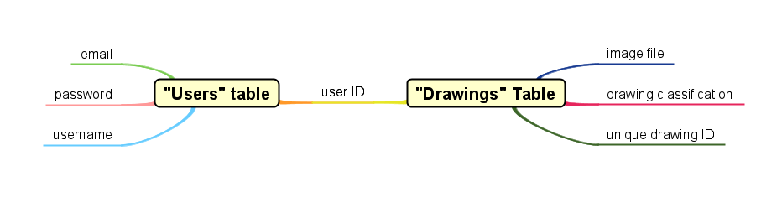

5.2 UML Diagrams

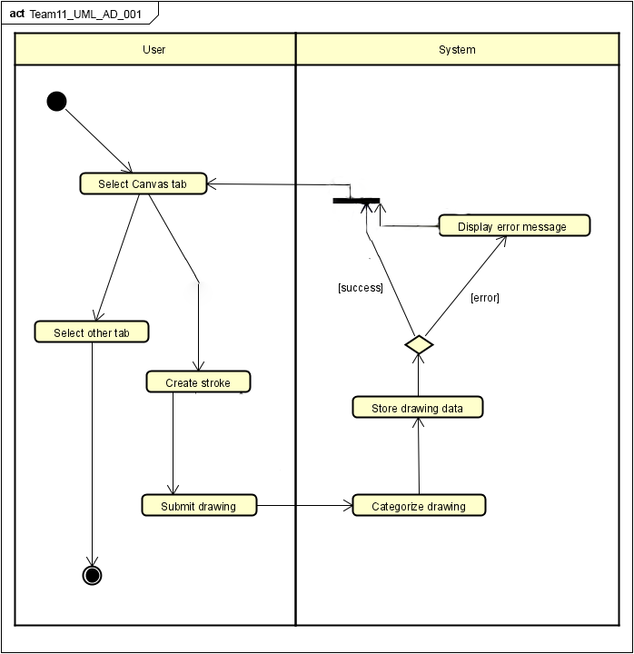

Figure: Activity Diagram -Canvas

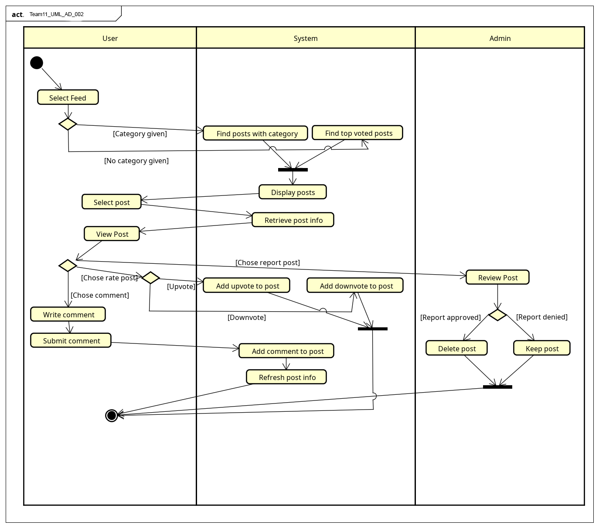

Figure: Activity Diagram- User Feed

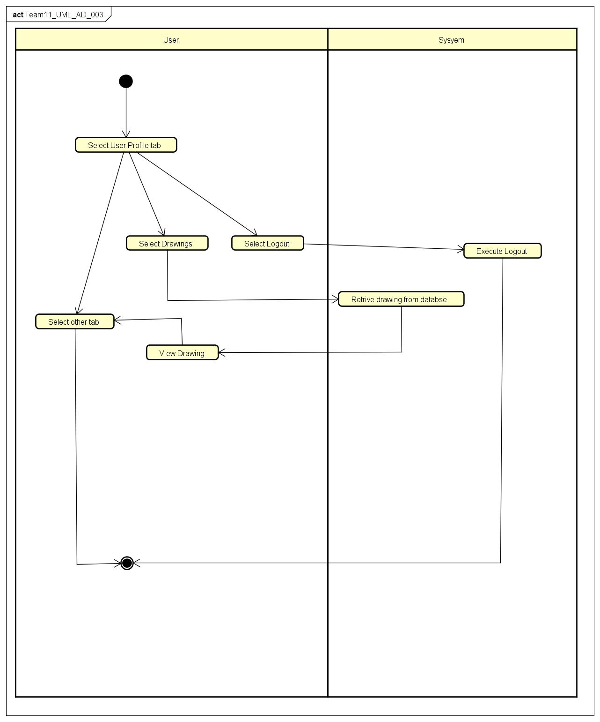

Figure: Activity Diagram- User Profile

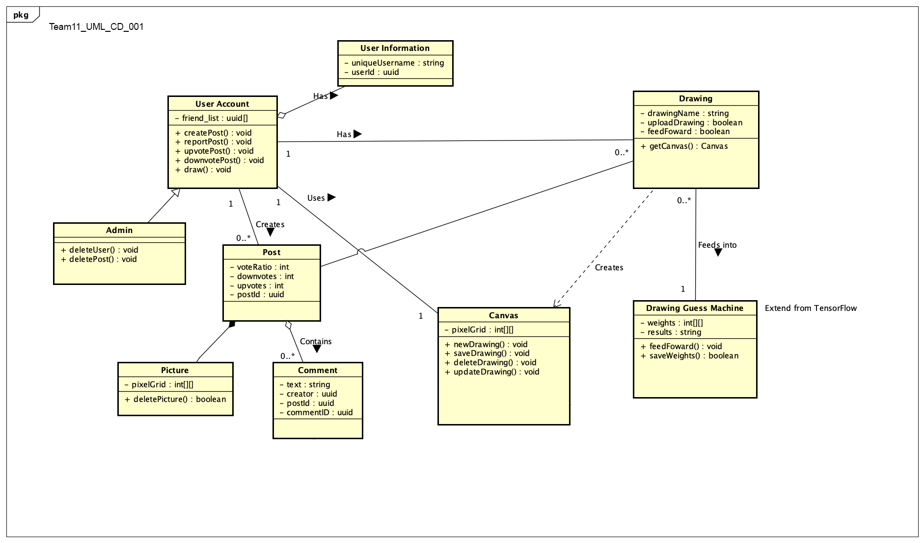

Figure: Class Diagram

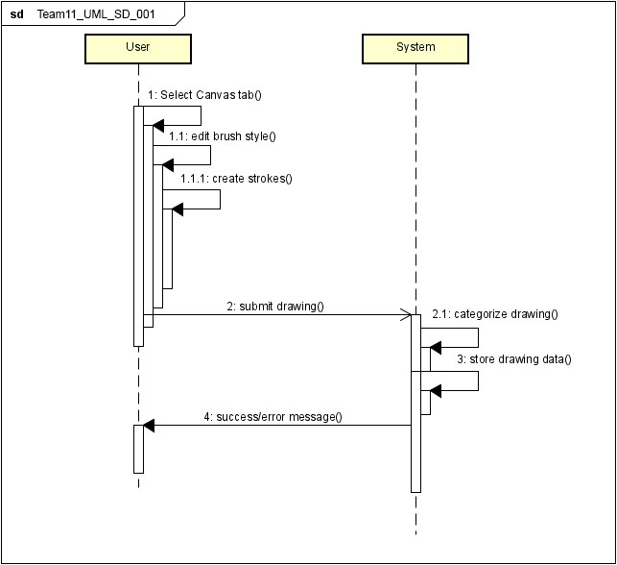

Figure: Sequence Diagram- Canvas

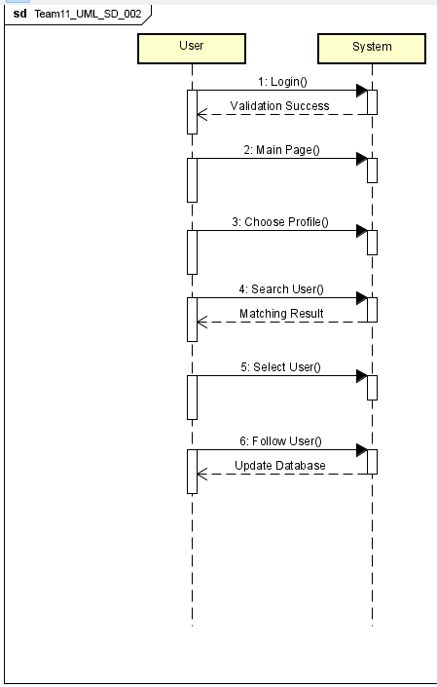

Figure: Sequence Diagram- Login

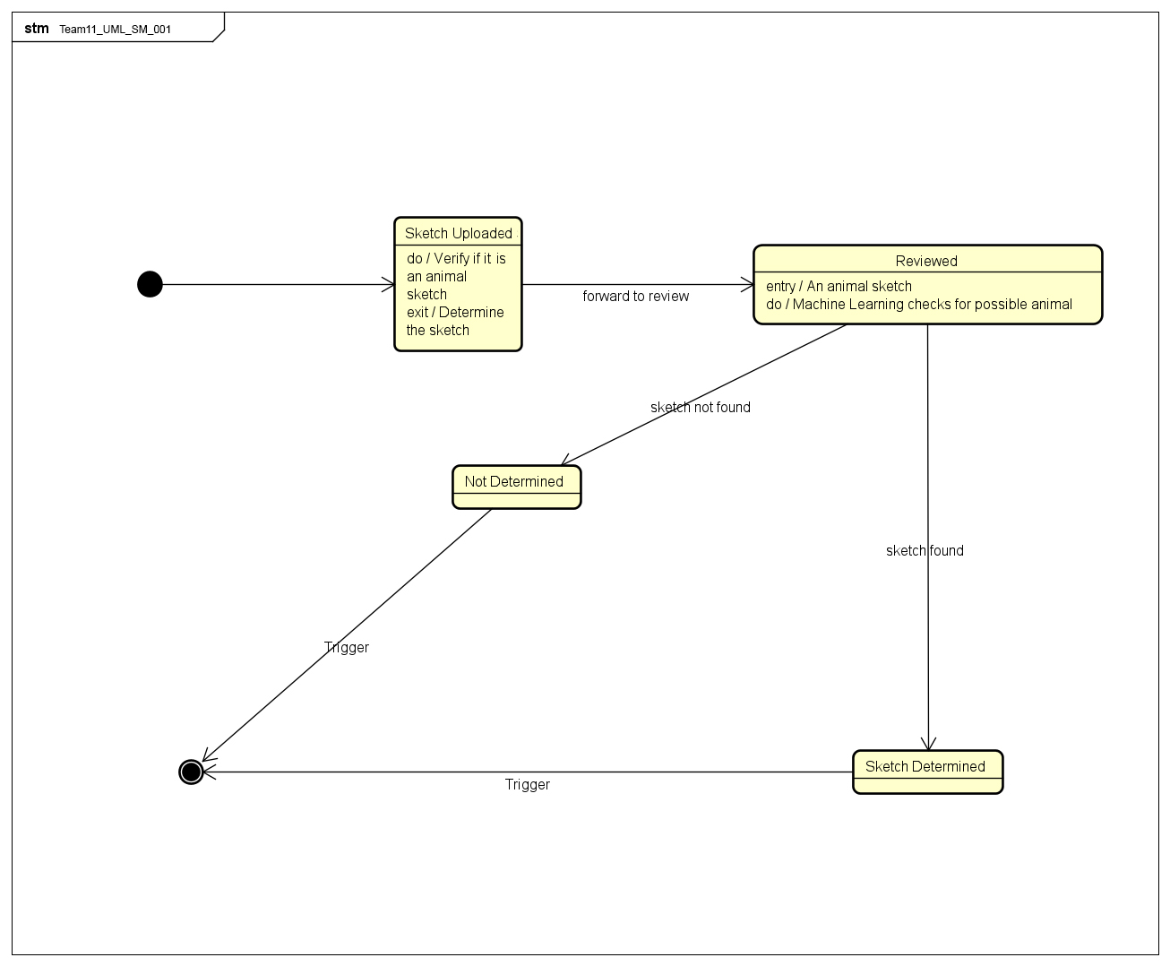

Figure: State Machine Diagram

Figure: Use Case Diagram

5.4 Screen Shots
None available at this time.

5.5 Test Plan
A test plan will be provided at a later stage of the project.

6. Assumptions and Constraints

6.1 ASSUMPTIONS
The following is a list of assumptions:
- All users are 13+ in age.
- The project will not need maintenance/ evolution after initial release.

6.2 CONSTRAINTS
The following is a list of constraints:
- Team does not have enough experience with database implementation.
- Team does not have enough experience with Machine Learning.

6.3 Out of Scope material
The following is a list of “out of scope” material:
- Post Project activities are not covered.

7. Delivery and Schedule

Task/Milestone Description | Anticipated Start Date | Anticipated End Date | Status | Comments
UML diagrams | 9/1/2020 | 10/1/2020 | Complete
SRA document (Includes project objectives, Requirements and UML diagrams) | 10/6/2020 | 10/22/2020 | In Progress | Deliverable will be the SRA document. All stakeholders agree on the content of the SRA by signing in section 8.  Increment 2 Deliverable
Web-scraping tool finished. | 10/22/2020 | 10/29/2020 | In Progress | Complete Tool to start implementing SketchApp.
Initial App Layout | 10/22/2020 | 10/29/2020 | In Progress | Finish skeleton for App XML.
Implement Database | 10/30/2020 | 11/6/2020 | Not Started | Finish database table and ORM setup.
Implement Drawing Feature | 10/30/2020 | 11/15/2020 | Not Started | Implement drawing board and tools.
Train N.N. | 11/10/2020 | 11/15/2020 | Not Started | Train NN using Google Doodle data.
Test Plan and CPRs | 11/10/2020 | 11/12/2020 | Not Started | Deliverables will be the Test Plan and CPRs.
Implement User Page | 11/10/2020 | 11/20/2020 | Not Started | Implement User Pages.
Final Product and Presentation | 11/20/2020 | 12/10/2020 | Not Started | Final Presentation and Packing of Product. Deployment to Android Play Store.

8. Stakeholder Approval Form

Stakeholder Name | Stakeholder Role | Stakeholder Comments | Stakeholder Approval Signature and Date
Rodrigo Augusto | Development Manager
Prajwal Gautam | Project Assistant
Gabriel de Sa | Developer |  | Gabriel de Sa  10/22/2020
Lucas Streanga | Developer |  | Lucas Streanga  10/22/2020
Luke Brown | Developer |  | Luke Brown  10/22/2020
Saugat Pandey | Developer |  | Saugat Pandey  10/22/2020
David Rademacher | Developer |  | David Rademacher 10/22/2020

Appendix:

None

